**Student Questions**

Learn about the internals of a standard PC case by examining physical samples and selecting and labeling images found on-line. Gain deeper knowledge by researching and reporting on specific components.

PC Tower Case

1. **Find one (or more) images that clearly show the internals of a PC Tower Case.   
   (i.e. Google images using keywords “PC Case Internals”)**
2. **Clearly label the following components (using arrows) on your image of the PC case internals:**

* Motherboard, Power Supply, Hard Disk Drive, Optical Disk Drive (e.g.DVD), USB Expansion Ports, Monitor Port, Audio Ports, Ethernet Port and cooling fan.

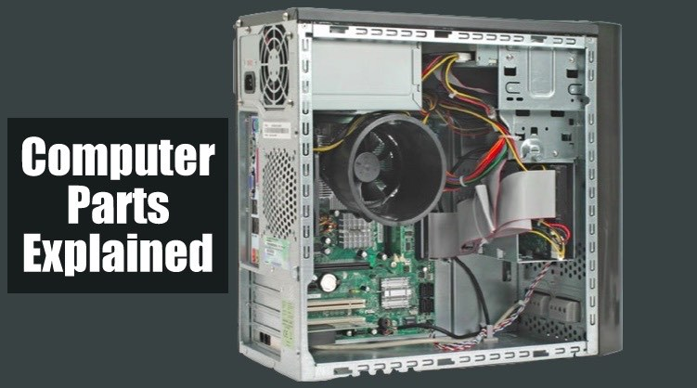

Optical Disk Drive

Hard Disk Drive

Cooling Fan

Motherboard

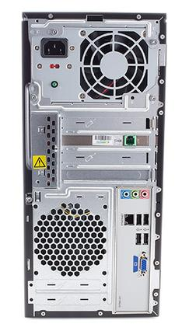

Power Supply

Audio Ports

USB Expansion Ports

Monitor Ports

Ethernet Port

1. **Research more in-depth about “Hard Disk Drives”. Make notes on the following:**
   1. **What different versions are currently available (speed and capacity)**
   2. **How the capacity of the component has changed since the 1980’s**

**PC Motherboard**

**Find one (or more) images that clearly show the layout of a PC Motherboard.   
(i.e. Google images using keywords “PC Motherboard”)**  
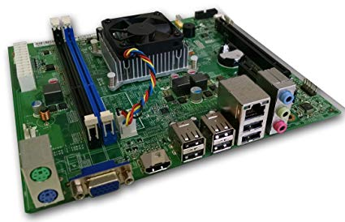

Graphic card

t

Soundcard

t

t

WIFI

IDE

**t**

RAM Memory

t

CPU

**t**

1. **Clearly label the following components (using arrows) on your image of the PC motherboard:**
   1. **CPU (and fan)**
   2. **RAM Memory**
   3. **Disk Drive Interface (IDE or SATA)**
   4. **GPU Graphics Processor (either on-board or Graphics Card)**
   5. **Sound Processor (either on-board or Sound Card)**
   6. **Wi-Fi / Ethernet Network Interface (either on-board or Graphics Card)**

1. **Research more in-depth about “CPU Processor Chip”. Make notes on the following:**
2. **What different versions are currently available (speed and capacity)**
   * Since 2009, there has been a total of seven different CPU processing chips including Intel Pentium, Intel Core, Intel Core 2, Intel Core i3, Intel Core i5, Intel Core I7, Intel Core i1 (Extreme), Intel Core i9, Intel Core i9, and Intel Core i9 (extreme)
3. **How the speed of the component has changed since the 1980’s**
   * In 1971, the processing chip’s bus speed was 400 MHz, 533 MHz. Now, the processing chip’s bus speed is 1066 MHz, 1600 MHz.

Peripheral Devices

1. Find one (or more) images that clearly show the layout of the back of a typical PC tower case.   
   (i.e. Google images using keywords “Back Of PC Tower”)
2. Clearly label the following components (using arrows) on your image of the back of a typical PC tower case:
   1. Power cord and power switch
   2. Monitor Interface (VGA or DVI or HDMI)
   3. Mouse Interface (USB or PS/2)
   4. Keyboard Interface (USB or PS/2)
   5. USB Ports
   6. Audio Inputs / Outputs
   7. Ethernet Interface

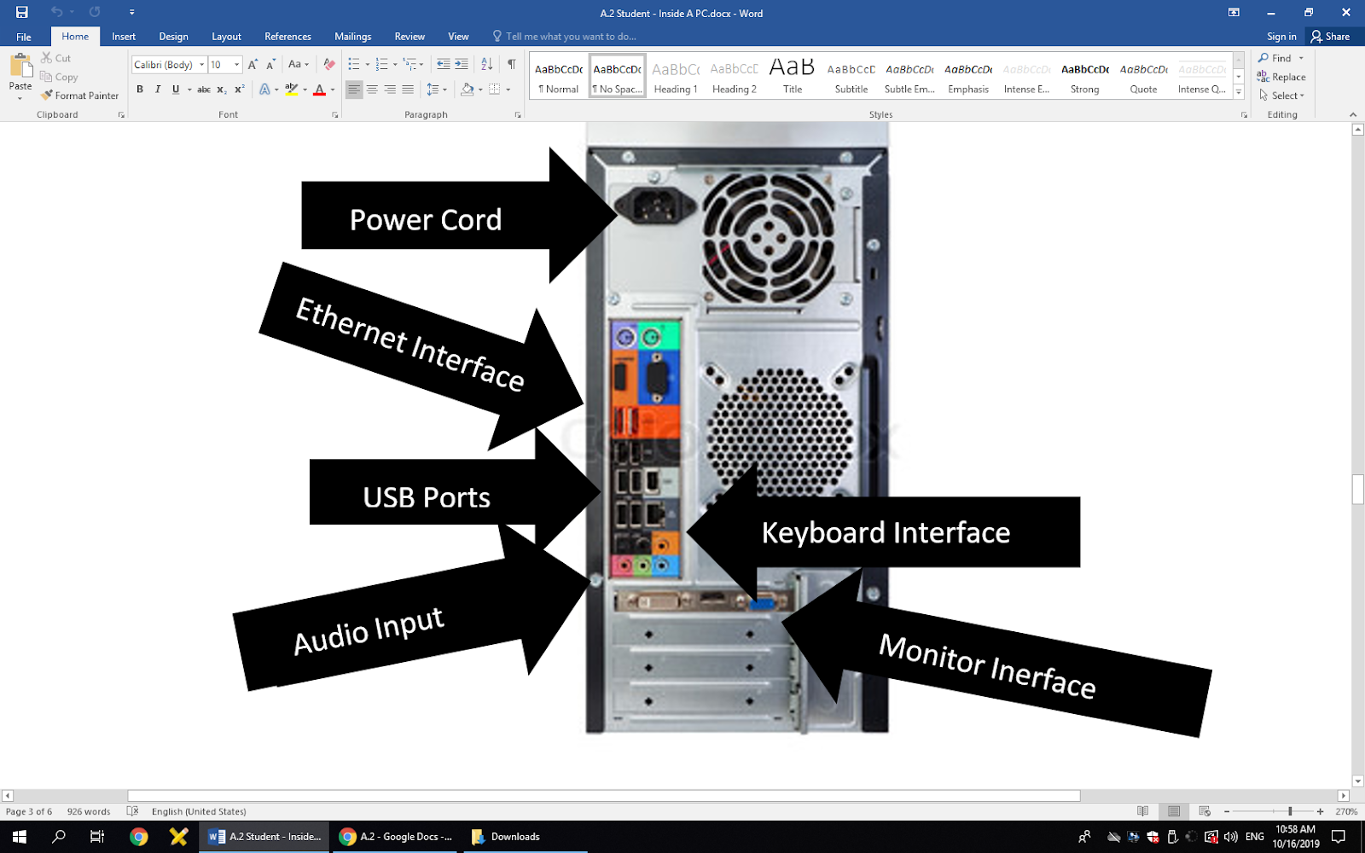

1. Research more in-depth about “External Portable Storage”. Make notes on the following:
2. **Floppy Disks**
   * Used to move information
3. **CD-ROM / DVD / Recordable CD/DVD**
   * 5 different types of DVDs
   * DVDs are used for videos and CD is used for audio
4. **USB Memory Drives**
   * Can hold up to 2 TB
5. **Compact Flash Memory**
   * Usually hold 8 GB
6. **Cloud Based Storage**
   * Apple used this
   * Cloud is safe